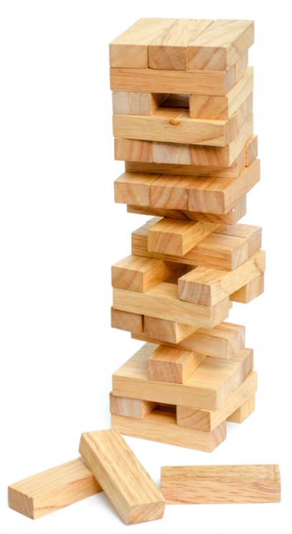
Want to play Stacks of Kindness?
- Move one piece each day.
- Traditional Jenga rules apply:
- Remove one block from any tower level (except the one below an incomplete top level).
- Place the block on the topmost level.
- If the block you chose says WINNER, do not place it on top of the tower. Bring your block to <INSERT NAME> to exchange it for a prize.
- If you don’t choose a winning block, place it on the tower and complete the suggested random act of kindness.

