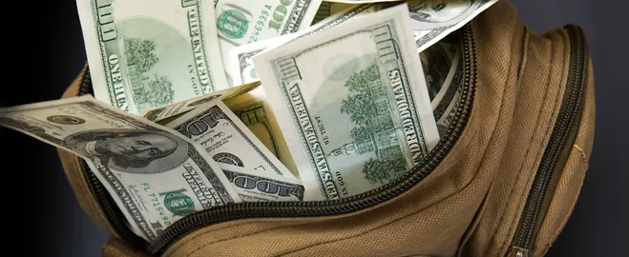

MONEY BAG Contest

<Insert DATES (4 to 6 weeks recommended)>

The money is where the LISTINGS are! Compete to win cash prizes by conducting listing presentations and getting signed listing agreements. For every qualified action,
you get to draw a prize token from the Money Bag at the weekly sales meeting.
Additional details and activity trackers will be provided on <INSERT DATE> at <INSERT LOCATION>.

To participate, please add your name to the Money Bag sign-up sheet posted in the <INSERT LOCATION> or email <INSERT EMAIL ADDRESS> by <INSERT DATE>.

Winners will draw prizes at each sales meeting.

