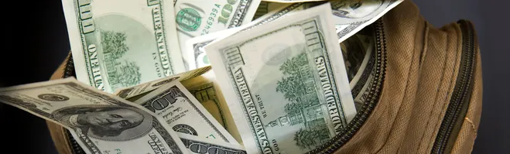

MONEY BAG Contest

<Insert DATES (4 to 6 weeks recommended)>

RULES
- Qualified agents will draw for prize tokens at each sales meeting.

- Agent must be present and bring their completed activity tracker to the sales meeting immediately following the date of the executed activity to be eligible for a prize.

- Each new fully executed Listing Agreement earns one draw from the Money Bag. Listing Agreement requirements:
- A minimum of <INSERT percentage> commission
- Listing period must be a minimum of <INSERT # OF MONTHS> months

- Bonus tokens are awarded for the following:
- $20 bonus token for a FSBO listing converted to a company listing (also receives a Money Bag draw for the listing). A picture of the FSBO yard sign is required.
- $5 bonus for completing a new listing presentation appointment (no Money Bag draw unless it results in a new listing agreement).

- A cash payout of prize winnings will be presented at the final contest sales meeting

